Date: 6th July 2020

1. I cannot edit “Default Rates” when I select the edit button.
2. In Default Rates, when I select +Create a new Default Rates the Rate Type and Rate Name should provide a drop down which shows all the current configured options for these entry options. Can you please configure these.
3. In Default Rates, when I select +Create a new Default Rates the titles Rate Per Click should read Rate Per Click ($) and in the cell below is should have $0.00 and allow you to modify it. The Monthly Threshold should be the same i.e. Monthly Threshold ($). Done The $ sign should appear in the Rate Per Click ($) and Monthly Threshold ($) in the Default Rates home page e.g. $0.05 (under Rate Per Click) and $1,000 (Monthly Threshold). Done

4a. In Billing Rate Setting the title on the page is incorrect as at the moment it reads Redirect Settings and Statistics. This should be renamed “Billing Rate Setting & Stats” on both the page and the left hand side pane. Done

4b. In Billing Rate Setting the Budget date should be e.g. $1,000 not 1000. And under Default Rate per Clicks the data should be $0.05 not 0.05. Under Custom Rate per Clicks($) the cells below should be larger and when there is no Custom entry it should empty and not even have 0. If there is a customer entry then it should be displayed as e.g. $0.05. Additionally it seems the Edit button under Modify seems to save the changes, so the button text should read **Save** rather than **Edit**.Done

4c. Add a “Stats” button which will replace the need for the “Budget Setting” page. If the Stats button is selected then a live current snapshot of the “Clicks”, “Amount Spent”, “Daily Average” and “Monthly Maximum” is displayed – as per below:

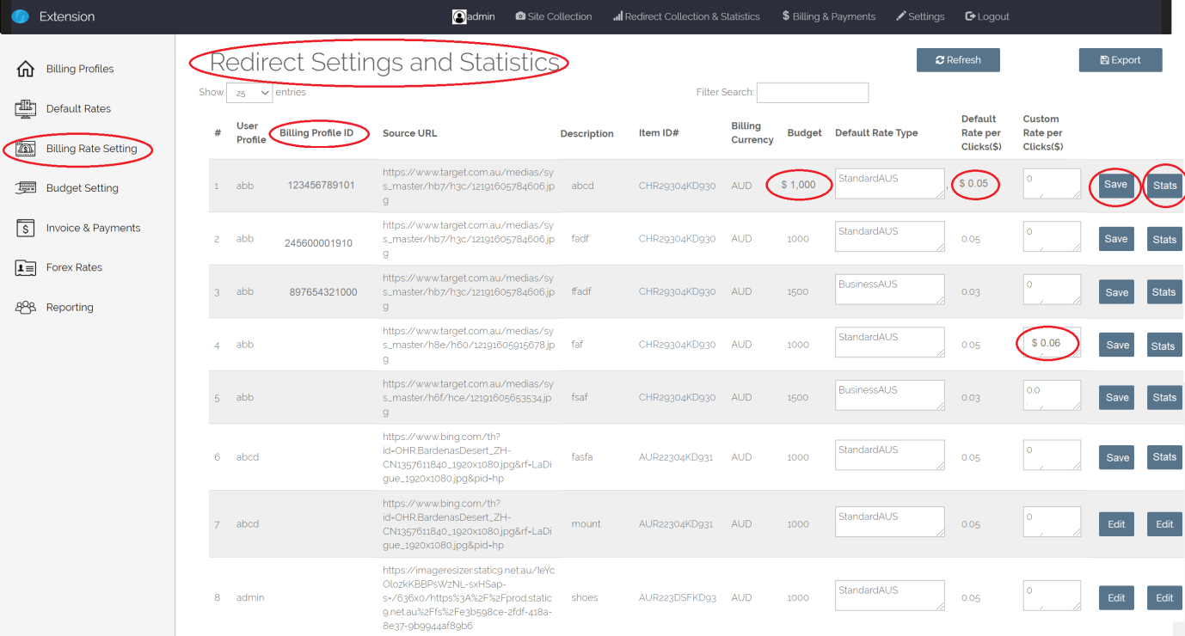

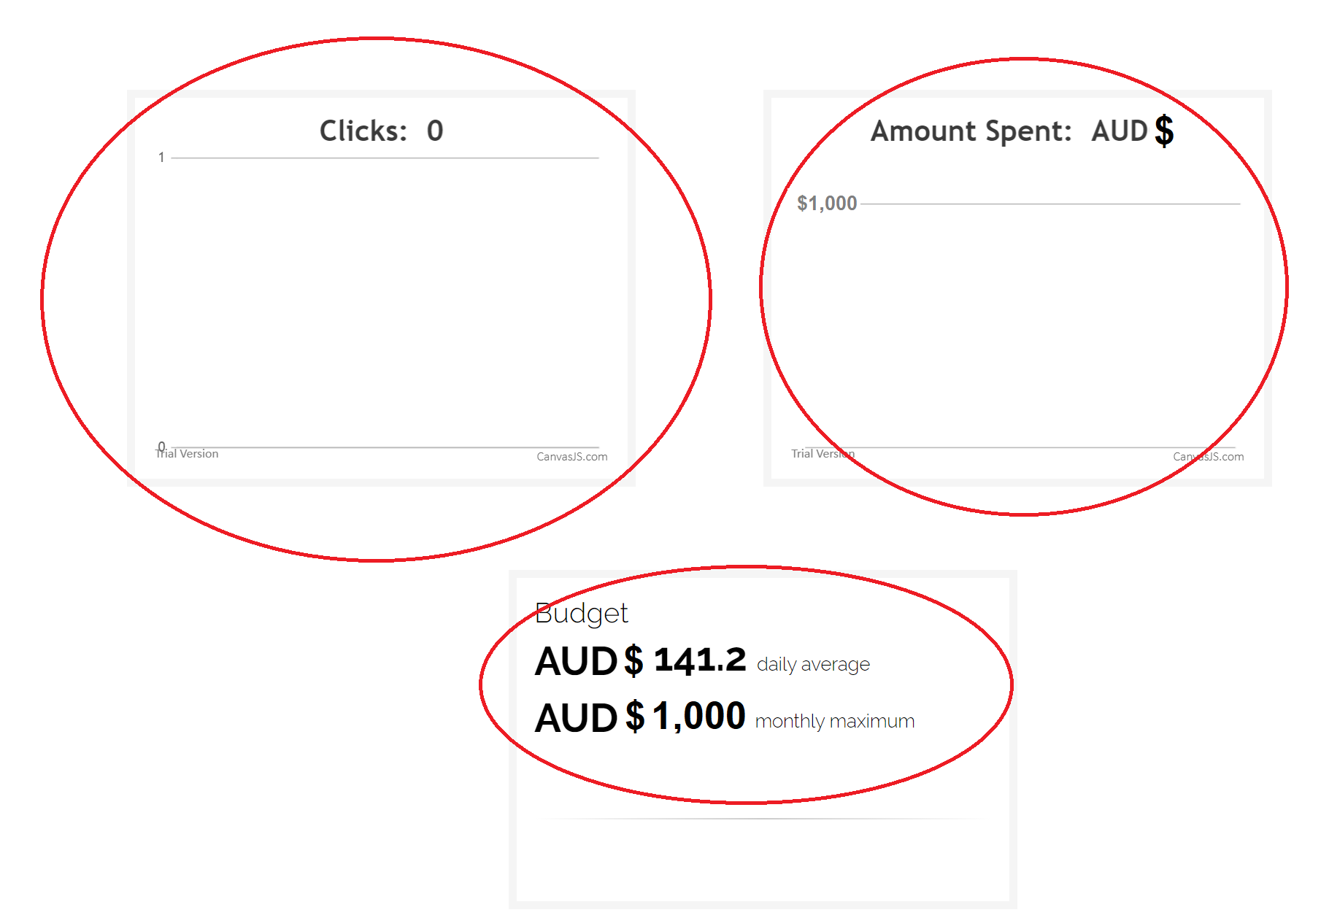

**Clicks**: Shows the current number of clicks registered against this item

**Amount Spent**: Shows current spent amount as a result of number of Clicks x rate

**Budget – daily rate**: is the current average daily spend at any point in time

**Budget – monthly maximum:** corresponds to the Budget setting configured on the Billing Rate Setting & Stats page.

1. On the Redirect Settings and Statistics page, if I filter on abb it appears that the ItemID#’s are all the same i.e. CHR29304KD930. All Items ID# should be unique. Please ensure this is the case.
2. On the Redirect Settings and Statistics page why doesn’t the Count column appear anymore? The Count is there to show how many times the URL Redirect was clicked in total. See below…

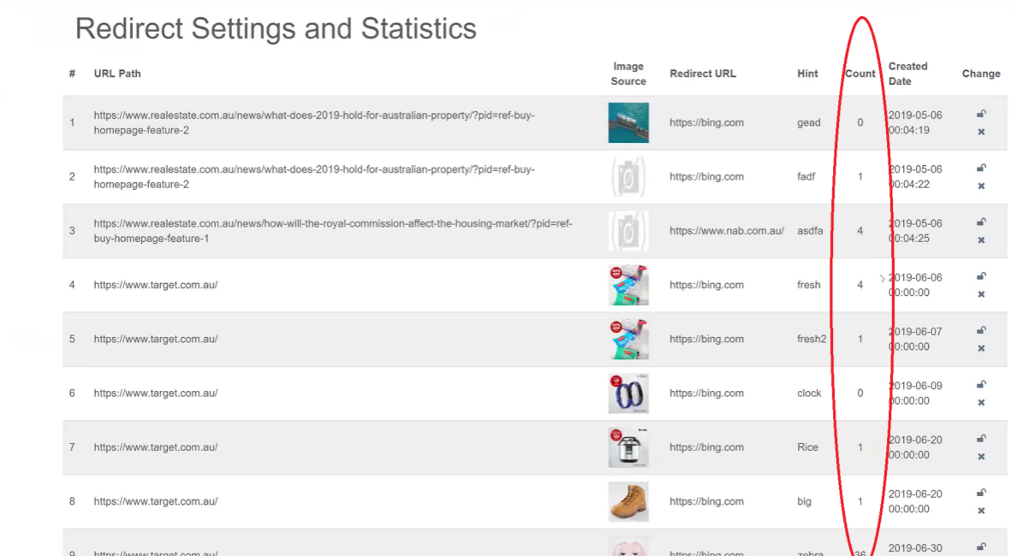

1. Replace Billing Profile ID with Account #. Additionally, rather than an email used the Account # should be a unique automatically generated 12 digit number e.g. 123456700000. Only Admin or user Manager (profile type) can have an automatic Account # generated. Standard Users will be associated with the Account # associated with the user Manager. A user Manager may have several Users associated with the user Manager’s Account #.(Done. Decide if which field should delete in create modal)

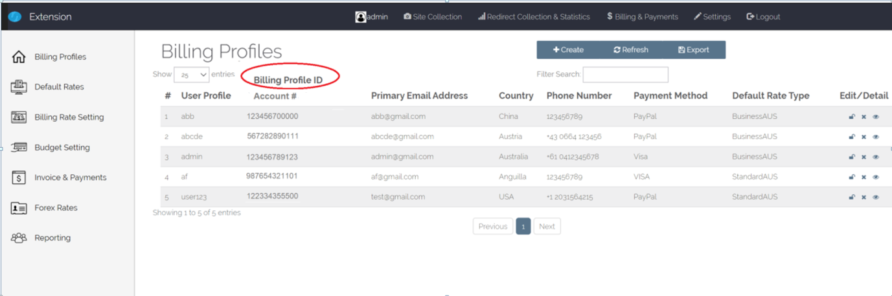

1. Change “Settings” name to “User Profiles”.Done Add the “Company” column which will allow a company or business to be captured against each User Profile – this should also appear as cell to fill when you +Add Profile.Done Additionally, add the “Account #” column which should be automatically reflected once the Account Number is set under Billing & Payments.Done If the select Test, then an automatic test email should be sent to the E-mail alias listed against the user. Done(Change Mail Setting )

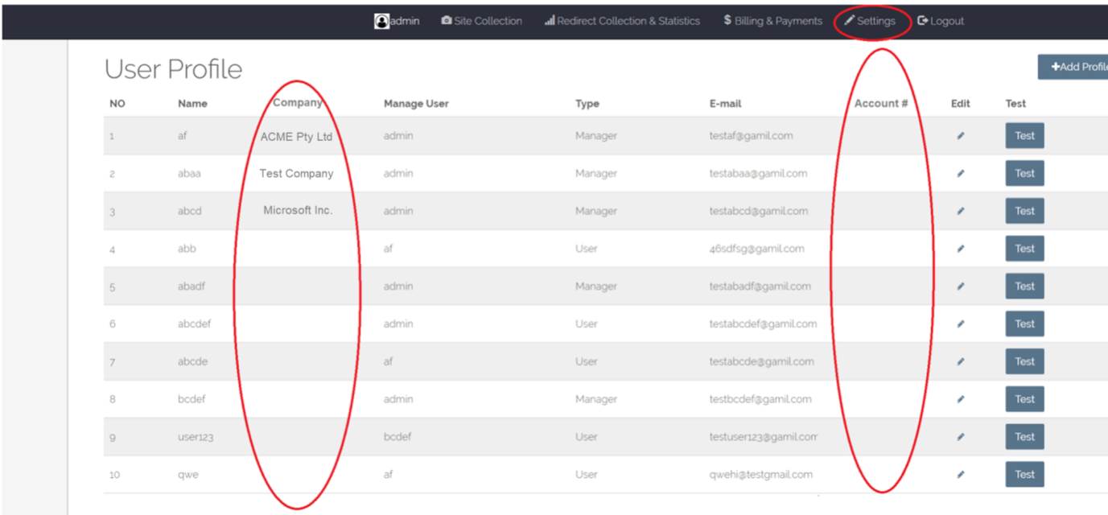

1. Changes required on the “Invoice & Payments” page:

* Billing Profile ID replaced with Account # Done
* Invoice Value should be reflect as e.g. $1,500 not 1500 Done
* The Invoice PDF should be replaced with the example format I have provided in the separate file (SPG Sample Invoice1.doc). Each invoice should capture all items associated with the specific Account #. (Style Done)
* Can you add a Payment Due Date column with all due dates being the 1st of next month e.g. for June 2020 invoice the Due Date is 01/07/2020 Done
* Note: that a Receipt# will only be generated and appear when the invoice is paid which should also capture the corresponding Payment Date. Done

